[**AWS Cloud Solution Architecture**](https://elearning.utdallas.edu/webapps/blackboard/execute/courseMain?course_id=_314357_1)

**Hands- On Projects**

By

**Manoj Mareedu**

Table of Contents

Lab 11: Configuring a static website on Amazon S3 3

Lab12. Get started with Amazon EC2 Linux instances. 4

Lab 13. Create a web server and an Amazon Aurora Cluster 5

Lab 14: Working with EBS 5

Lab 15: Send Messages Between Distributed Applications with Amazon Simple Queue Service (SQS) 8

Lab17: Create and Query a NoSQL Table with Amazon DynamoDB 11

Lab 18: Create an Audio Transcript with Amazon Transcribe 13

Lab 19: AWS Network Setup (VPC-ACLs-IGW and NATs) 15

Lab 20: AWS Well Architecture Lab 17

# Lab 11: Configuring a static website on Amazon S3

**Step3.5:**

Cleared Block all public access, and choosed Save changes after the saving my permissions.

**Step7.3**

At the bottom of the page, under Static website hosting, selected my Bucket website endpoint. My index document opens in a separate browser window.

# Lab12. Get started with Amazon EC2 Linux instances.

**Step9:**

Review a summary of your instance configuration in the Summary” panel before the lunch EC2

# Lab 13. Create a web server and an Amazon Aurora Cluster

. Created a DB Cluster, section Step 14

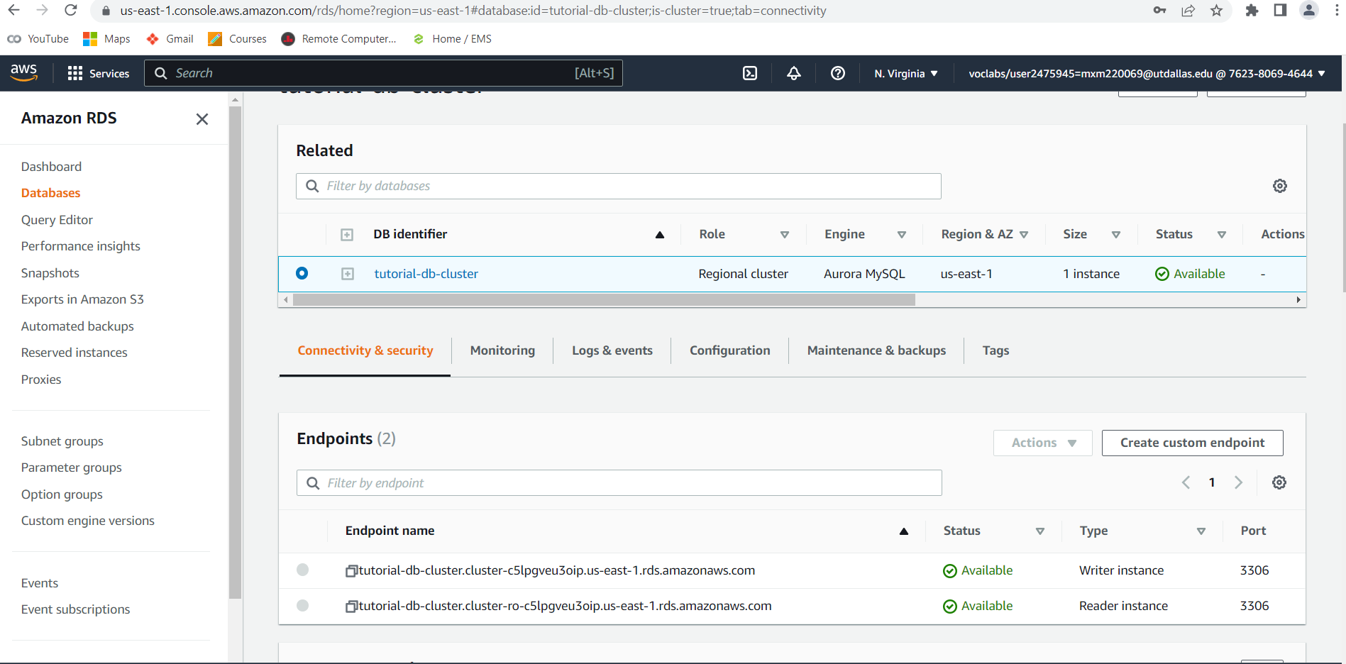



b. Installed a web server section Step 9

# Lab 14: Working with EBS

Task 1: Step 10. After creating the volume successfully.

Task 4: Step 30 Connected to instance and ran required Comands.

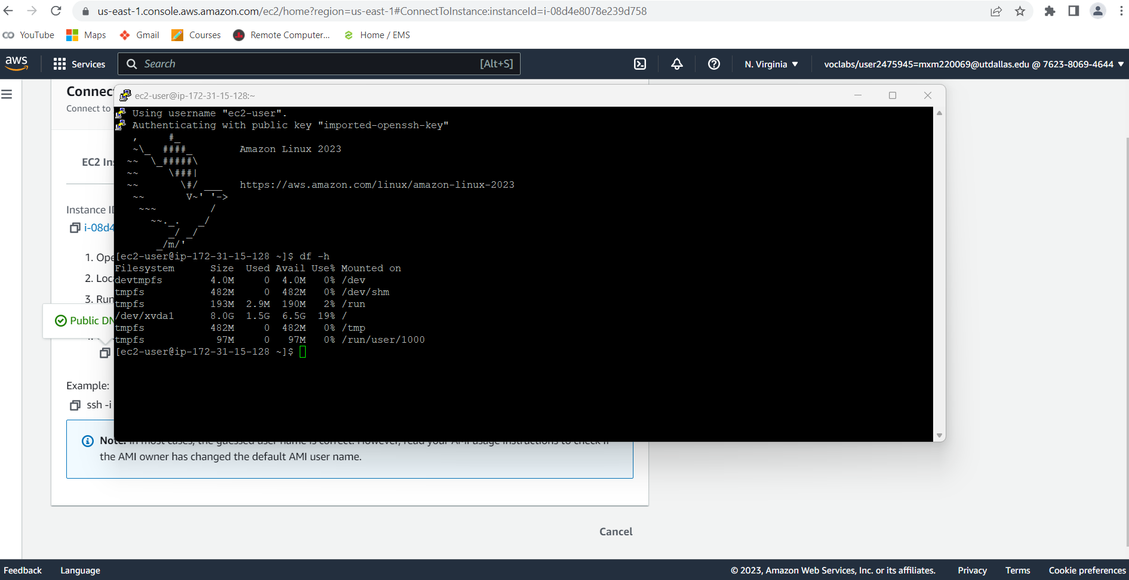

Task 4: step 35. Ran the given commands and presenting the output in the below image.

Task 5: Step 41. Created the snapshot.

Task 6: step 51. Restored from the snapshot.

Task 6: step 55. Verified the restored results.

# Lab 15: Send Messages Between Distributed Applications with Amazon Simple Queue Service (SQS)

Step 2: D screen shot of Queue Created.

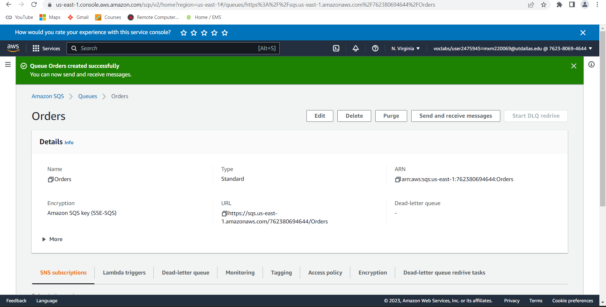

Step 3: b Sent the message as shown in the below image.

Step 3: d Sent the message as shown in the below image

Step 4 : b polled for messages.

# Lab17: Create and Query a NoSQL Table with Amazon DynamoDB

Step1: f screen shot. Created a table.

Step 2: c . Performed required tasks and below are the results.

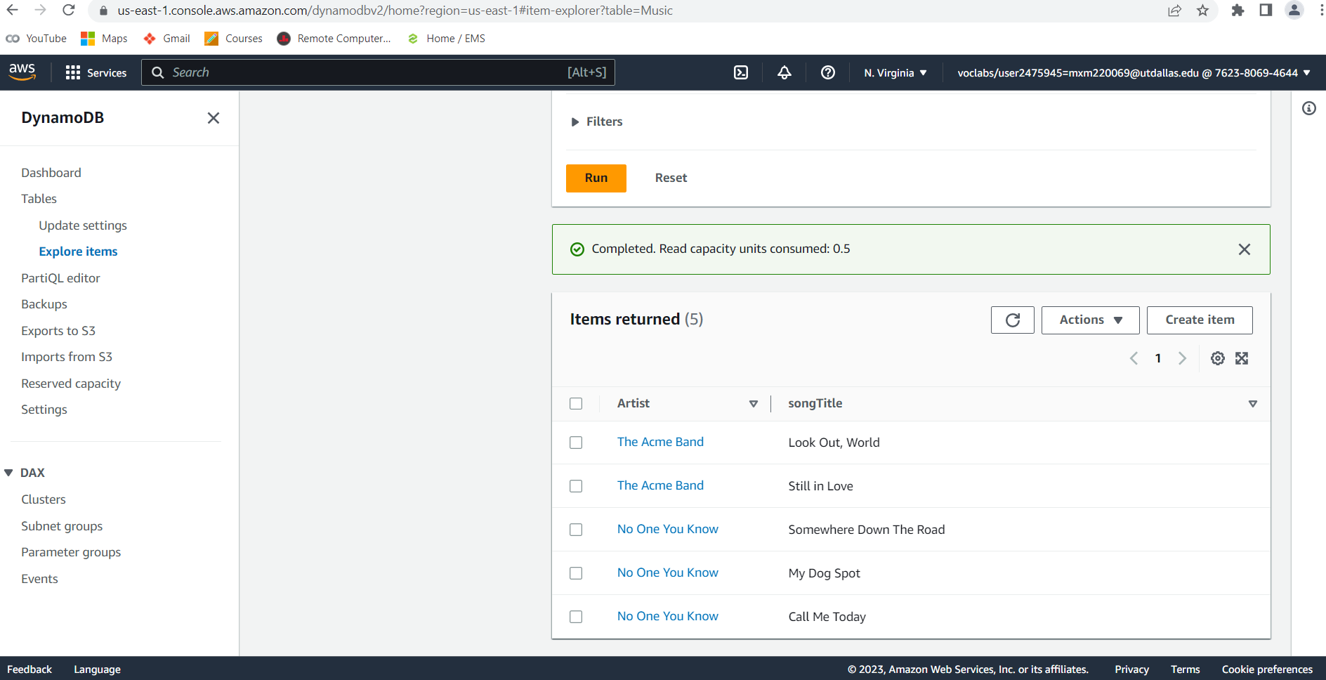

Step 3: b Ran query and observed the results.

Step3: c screen shot. Performed more complex query and verified the results.

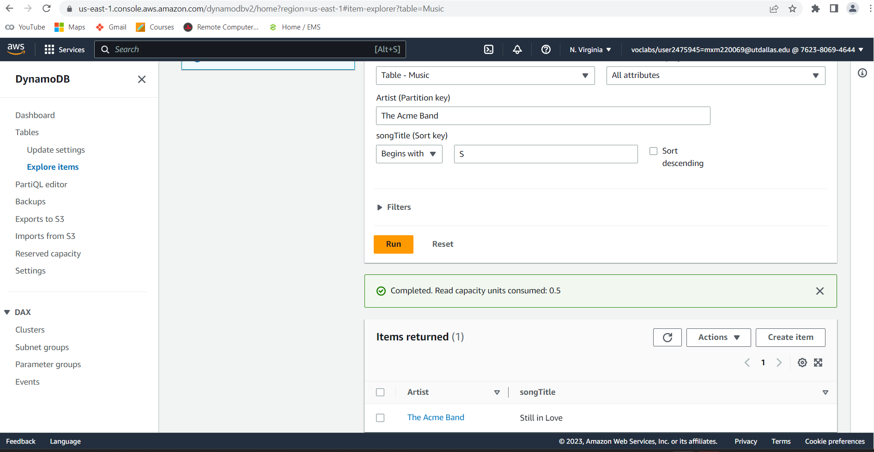

# Lab 18: Create an Audio Transcript with Amazon Transcribe

Step 1: k. Performed specified task and presenting the output in below image.



Step 2: d screenshot. Creating the transcription jobs.

Step 3: b screen shot. Observed the results shown in the below images.

# Lab 19: AWS Network Setup (VPC-ACLs-IGW and NATs)

1.Please save your EIP _______________________?

Ans) Elastic IP address 52.70.73.184

2. Want is your VPC-ID and Owner ID what you created step 12 ?

__________________________________ ( for Owner ID Select your MyVPC and look into

details tab below the page)

Ans) vpc id : vpc-0ffd491c997b447b3

ownerid: 401410386190

3. How many available IP v4 addresses for Public and Private subnets? ( step 17)

_____________ , ___________ are they same ? why/why not ? explain.

Ans: 251 private available subnets and 250 available public subnets.

AWS VPC (Virtual Private Cloud) setup, the number of available private and public subnets is determined by the CIDR block(s) that you allocate for your VPC. The CIDR block defines the range of IP addresses that can be used within the VPC and its subnets.

the number of available subnets can be calculated using the formula 2^(32-n), where n is the number of bits used for the network portion of the IP address

4.4. screenshot I took at step 27.

# Lab 20: AWS Well Architecture Lab

Step: 1.2.12 screenshot. Created a stack and verified subscription.

Step 2.15 image. Created backup plan.

Step 3: 4 Ran required commands in command prompt.

Step 4: 20 Validated the backup.

